Navigation to view Tax Form 1098-T:

*CURRENT and FORMER students will access their 1098-T online through Campus Connection.*

- Sign in to Campus Connection: www.NDSCS.edu/CampusConnection
- If you do not remember your User ID or Password, click on “Help Desk Support”, scroll down to the NDUS Account section, and follow the prompts. For further assistance, call 1-866-457-6387.
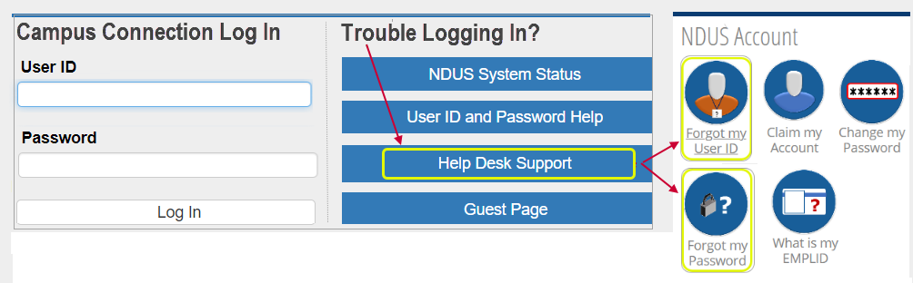

- Within Campus Connection, click on “Financial Account” tile, then click “View 1098-T”. There will be 2 tabs with 1098-T information: “General” & “Box Amount”.
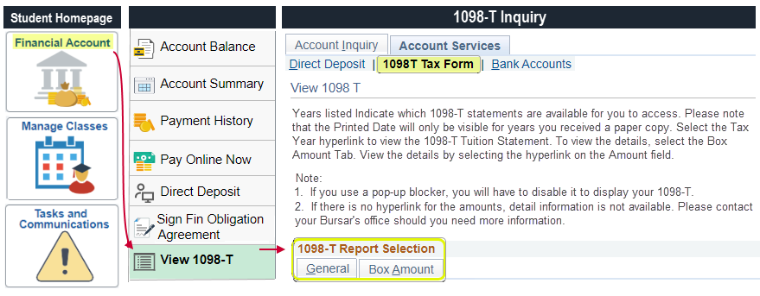

  - “General” tab – click on the tax year you want to view/print; it will open in another window.
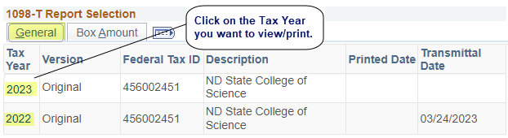

  - “Box Amount” tab – by clicking on an amount hyperlink, the details included in that amount will show.
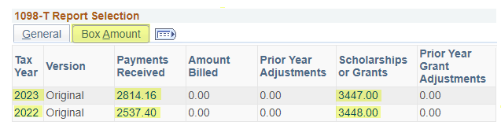

Sample of Form 1098-T:
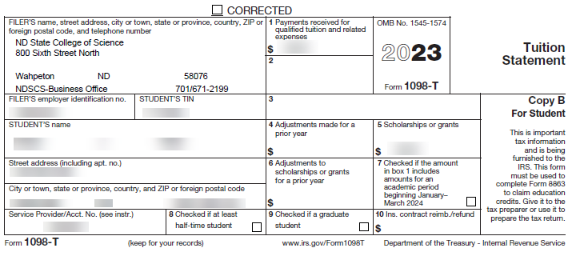

1098-T Box Explanations:
- Box 1 Payments Received – Shows payments received towards your NDSCS account that paid qualified tuition and related expenses during the tax year. Examples of payments included in Box 1: personal payments, loans, scholarships, grants, 3rd-party funding.
  - Payments received for costs that are not tuition-related (such as books) will not be reflected in Box 1, but may be eligible to use for calculating the Education Tax Credit; adequate personal financial records of these payments (ex. receipts, bank statements, etc.) may work as documentation for tax purposes.
- Box 2 - Reserved for future use.
- Box 3 - Reserved for future use.
- Box 4 Adjustments Made for a Prior Year - Shows any adjustments made to amounts that were previously reported on a prior year’s FORM 1098-T for qualified tuition and related expenses.
- Box 5 Scholarships or grants - Shows the total of all scholarships, grants or 3rd-party funding received during the tax year.
- Box 6 Adjustments Made for a Prior Year to Scholarships or Grants - Shows adjustments made to amounts that were previously reported on a prior year’s FORM 1098-T for scholarships, grants or 3rd-party funding.

For further information:
- Form 1098-T related information: www.irs.gov/form1098T
- Education Tax Credit information: www.irs.gov/form8863
- NDSCS 1098-T Information: www.NDSCS.edu/1098-T
- For questions relating to the specific amounts listed on your 1098-T that could not be answered by reviewing the information within the “Box Amount” tab (referenced above), you may call the NDSCS 1098-T line at 1-701-671- 2199 or 1-800-342-4325 ext. 3-2199.

01/28/2024

